**ASSIGNMENT – 04**

**DSA0163-Object oriented programming with C++**

**T Hemanth yadav**

**Reg no:192211685**

1. Write a c++ program to implement method overriding with your own application?

#include <iostream>

using namespace std;

class Shape {

public:

virtual void calculateArea() {

cout << "Calculating area of a Shape" << endl;

}

};

class Circle : public Shape {

public :

double radius;

Circle(double r) : radius(r) {}

void calculateArea() override {

double area = 3.14 * radius * radius;

cout << "Calculating area of a Circle: " << area << endl;

}

};

class Rectangle : public Shape {

public:

double length;

double width;

Rectangle(double l, double w) : length(l), width(w) {}

void calculateArea() override {

double area = length * width;

cout << "Calculating area of a Rectangle: " << area << endl;

}

};

int main() {

Circle circle(4.0);

Rectangle rectangle(5.0, 4.0);

Shape* shape1 = &circle;

Shape* shape2 = &rectangle;

shape1->calculateArea();

shape2->calculateArea();method

return 0;

}

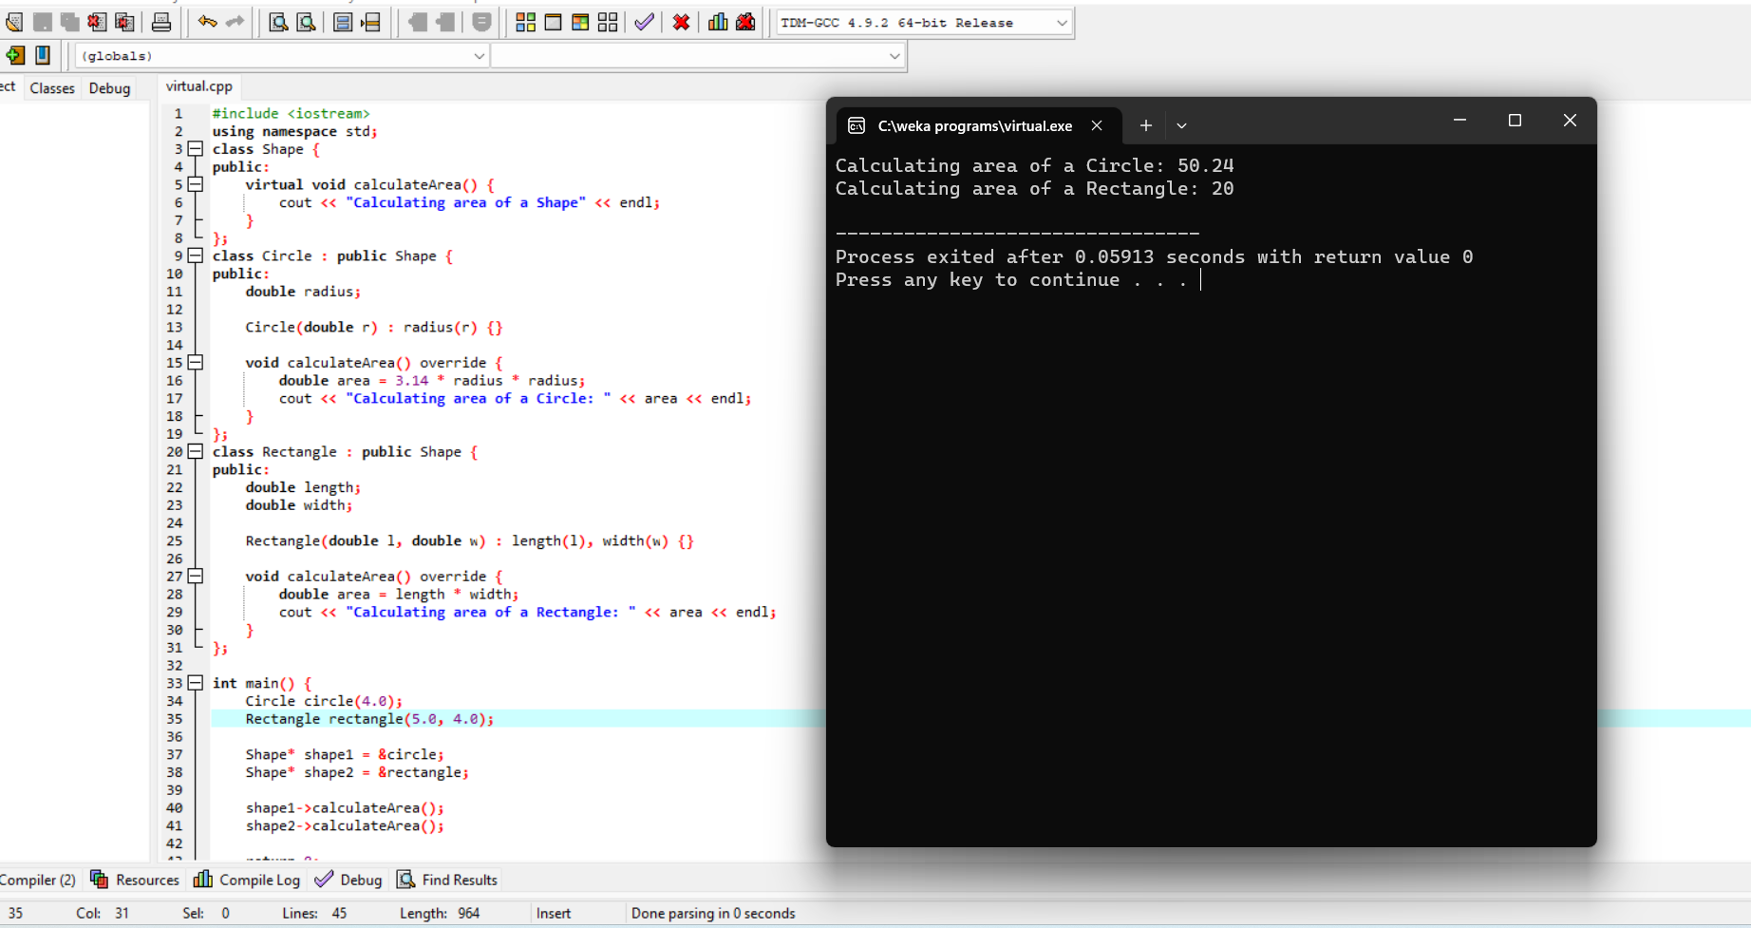

1. write a c++ program to implementing friend function?

#include <iostream>

using namespace std;

class Student {

private:

int data;

public:

Student(int value) : data(value) {}

friend void DisplayData(const Student &obj);

};

void DisplayData(const Student &obj) {

cout << "Data in Student: " << obj.data << endl;

}

int main() {

Student obj(42);

DisplayData(obj);

return 0;

}

